**Library Management System**



**Database Systems**

**BSDS 4-1**

**Semester Project**

**Supervised By**

**Mr. Mueed Ahmed**

**Faculty of Computing**

**Riphah International University**

**1. Executive Summary 4**

**2. Project Objectives 4**

**3. System Architecture 4**

3.1 System Components 4

**4. Requirements Specification 5**

4.1 Functional Requirements 5

4.1.1 Librarian Functional Requirements 5

1. Book Management 5

2. Publisher Management 5

3. User Management 5

4.1.2 Reader Functional Requirements 5

1. Book Interaction 5

2. Order Tracking 5

4.2 Non-Functional Requirements 6

1. Performance Requirements 6

2. Security Requirements 6

3. Usability Requirements 6

4. Reliability Requirements 6

5. Scalability Requirements 6

7. Maintainability Requirements 6

**5. System Design Diagrams 7**

5.1 Entity-Relationship Diagram (ERD) 7

5.2 Class Diagram 8

5.3 Database Schema Diagram 9

5.4 Use Case Diagram 10

**6. Actors and Use Case Descriptions 11**

6.1 Actors 11

6.2 Use Case Descriptions 12

Librarian Use Cases 12

a) Add Book 12

b) View Books 12

c) Add Publisher 12

d) View Publishers 12

e) View Members 12

f) View Borrow Requests 13

g) View Borrowed Books / Transactions 13

h) Issue Fine 13

Reader Use Cases: 13

a) Register 13

b) Login 13

c) Search Books 13

d) Request Book 14

e) View Borrowed Books 14

f) View Fines 14

g) Return Book 14

h) Update Profile 14

**7. Technology Stack 15**

**8. Future Enhancements 15**

**9. Conclusion 15**

Library Management System

Project Report

# 1. Executive Summary

The Library Management System is a comprehensive software solution designed to streamline library operations, enhance user experience, and provide efficient book management capabilities for both librarians and library members. This project aims to digitize and automate key library processes, improving accessibility, tracking, and overall library management.

# 2. Project Objectives

* Develop a robust digital system for managing library resources
* Provide an intuitive interface for librarians and library members
* Automate book ordering, tracking, and management processes
* Improve efficiency of library operations
* Enhance user experience for book borrowing and returns

# 3. System Architecture

## 3.1 System Components

* User Management Module
* Book Management Module
* Publisher Management Module
* Authentication Module

# 4. Requirements Specification

## 4.1 Functional Requirements

### **4.1.1 Librarian Functional Requirements**

#### **1. Book Management**

* Add new books to the library catalog
* View existing book details
* View borrowed books information

#### **2. Publisher Management**

* Adding new publishers
* Contact info

#### **3. User Management**

* Manage reader accounts

### **4.1.2 Reader Functional Requirements**

#### **1. Book Interaction**

* Browse available books
* Place book orders
* Return borrowed books

#### **2. Order Tracking**

* View borrowed books
* Check books detail
* Fines accommodation

### **4.2 Non-Functional Requirements**

#### **1. Performance Requirements**

* System should respond to user queries instantly
* Support concurrent user access
* Maintain system performance with a catalog of 10,000+ books

#### **2. Security Requirements**

* Implement robust user authentication
* Role-based access control
* Encrypted password storage

#### **3. Usability Requirements**

* Intuitive and user-friendly interface

#### **4. Reliability Requirements**

* Error logging and monitoring
* Graceful error handling

#### **5. Scalability Requirements**

* Support library growth
* Ability to add new features without major system redesign

#### **7. Maintainability Requirements**

* Modular code structure
* Comprehensive documentation
* Easy system updates and patches

# 5. System Design Diagrams

## 5.1 Entity-Relationship Diagram (ERD)

## 

## 5.2 Class Diagram

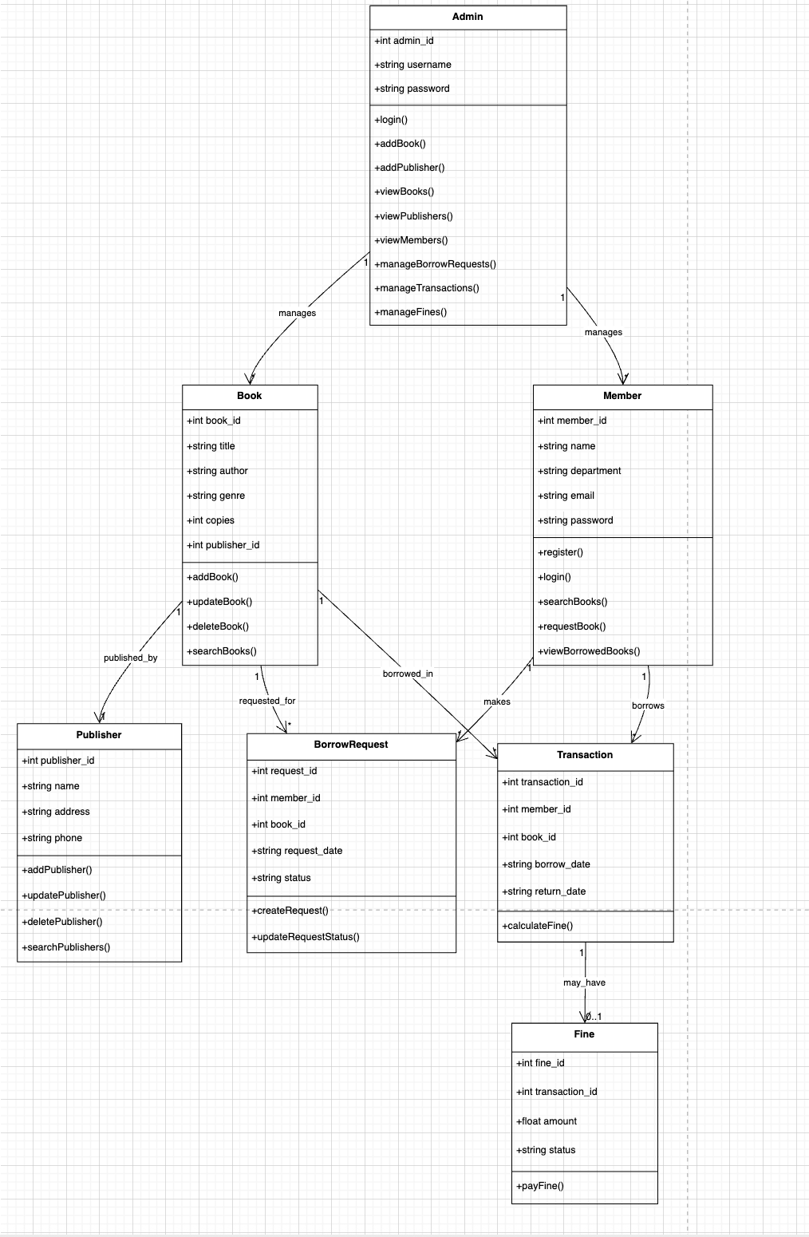

## 5.3 Database Schema Diagram

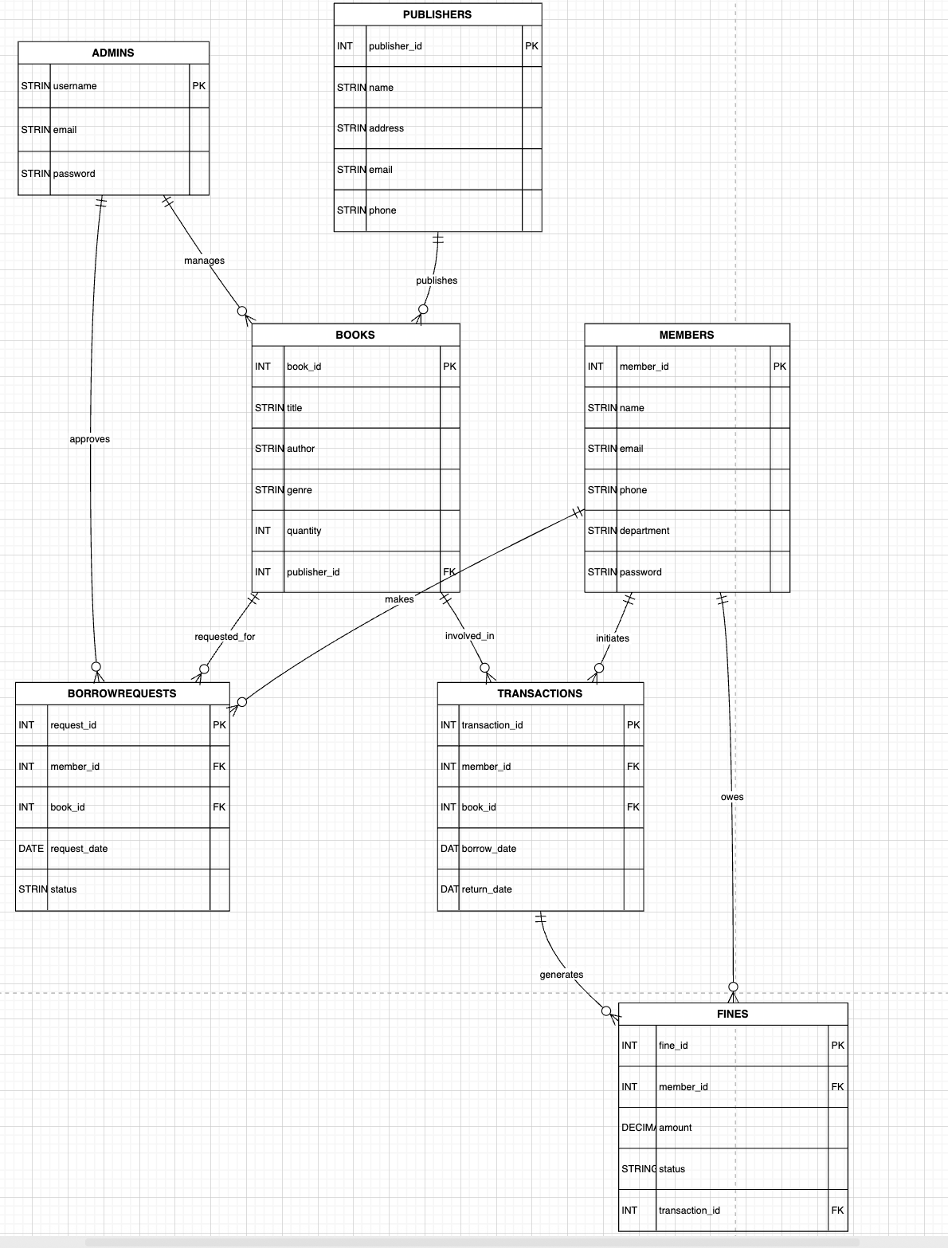

## 5.4 Use Case Diagram

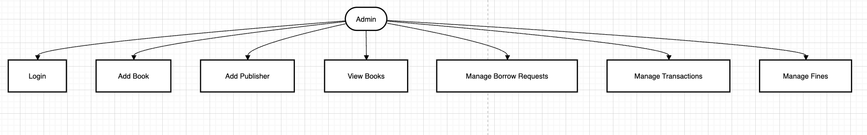

*Figure 1.In Admin case*

*Figure 2.In Member case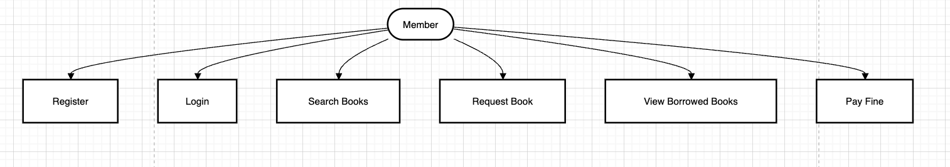*

# 6. Actors and Use Case Descriptions

## 6.1 Actors

1. Librarian

2. Library Member (Reader)

## 6.2 Use Case Descriptions

### **Librarian Use Cases**

#### **a) Add Book**

* **Description:** Allows the admin to add a new book to the system.
* **Actors:** Admin
* **Preconditions:** Admin is logged in
* **Main Flow:**
  + Admin enters book title, author, genre, number of copies, publisher
  + System checks if any field is empty or book already exists
  + If valid, book is added to the database
* **Alternate Flow:**
  + If book with same title already exists → Show error
  + If quantity is not numeric → Show error

#### **b) View Books**

* **Description:** Allows the admin to view and search existing books.
* **Actors:** Admin
* **Preconditions:** Admin is logged in
* **Main Flow:**
  + Admin opens the "View Books" page
  + Can filter/search by title or genre
  + System displays matching books

#### **c) Add Publisher**

* **Description:** Admin can register a new publisher.
* **Actors:** Admin
* **Preconditions:** Admin is logged in
* **Main Flow:**
  + Admin enters publisher name and contact
  + System checks if publisher already exists
  + Adds publisher to the database
* **Alternate Flow:** Duplicate entry → Show error

#### **d) View Publishers**

* **Description:** Admin views the list of registered publishers.
* **Actors:** Admin
* **Preconditions:** Admin is logged in
* **Main Flow:**
  + Admin opens the "View Publishers" page
  + System displays publisher list

#### **e) View Members**

* **Description:** Displays all registered members.
* **Actors:** Admin
* **Preconditions:** Admin is logged in
* **Main Flow:**
  + Admin selects “View Members”
  + System fetches and shows all member records

#### **f) View Borrow Requests**

* **Description:** Displays and manages pending borrow requests from members.
* **Actors:** Admin
* **Preconditions:** Admin is logged in
* **Main Flow:**
  + Admin selects a pending request
  + Can approve or reject the request
  + System updates book availability and request status

#### **g) View Borrowed Books / Transactions**

* **Description:** Shows books currently borrowed and complete transaction history.
* **Actors:** Admin
* **Preconditions:** Admin is logged in
* **Main Flow:**
  + Admin views transaction records including borrowed and returned books

#### **h) Issue Fine**

* **Description:** Admin can issue a fine for overdue books.
* **Actors:** Admin
* **Preconditions:** Book is overdue
* **Main Flow:**
  + Admin selects a transaction
  + Enters fine amount and remarks
  + System records fine

### **Reader Use Cases:**

#### **a) Register**

* **Description:** New member registration.
* **Actors:** Member
* **Preconditions:** Member is not yet registered
* **Main Flow:**
  + Member enters name, department, email
  + System generates a password (member ID)
  + Sends login credentials via email

#### **b) Login**

* **Description:** Login for existing member.
* **Actors:** Member
* **Preconditions:** Member must have credentials
* **Main Flow:**
  + Member enters member ID and name
  + System authenticates and opens dashboard

#### **c) Search Books**

* **Description:** Allows searching for books by title or genre.
* **Actors:** Member
* **Preconditions:** Member is logged in
* **Main Flow:**
  + Member enters search term
  + System displays matching results

#### **d) Request Book**

* **Description:** Member requests a book to borrow.
* **Actors:** Member
* **Preconditions:** Book is available
* **Main Flow:**
  + Member selects book
  + Clicks "Request"
  + System adds request to borrow queue

#### **e) View Borrowed Books**

* **Description:** Shows books currently issued to the member.
* **Actors:** Member
* **Preconditions:** Member is logged in
* **Main Flow:**
  + Member clicks "View Borrowed Books"
  + System displays titles and due dates

#### **f) View Fines**

* **Description:** Member can view any pending fines.
* **Actors:** Member
* **Preconditions:** Member has overdue returns
* **Main Flow:**
  + Member opens "Fines" section
  + System shows fine amount and related transaction

#### **g) Return Book**

* **Description:** Allows the member to return a borrowed book.
* **Actors:** Member
* **Preconditions:** Book is borrowed
* **Main Flow:**
  + Member selects a borrowed book
  + Clicks "Return"
  + System updates the transaction and marks book as returned

#### **h) Update Profile**

* **Description:** Member can update their personal details (name, department, email).
* **Actors:** Member
* **Preconditions:** Member is logged in
* **Main Flow:**
  + Member accesses "Update Profile"
  + Edits name, department, or email
  + System validates and updates data

# 7. Technology Stack

* **Frontend** : Python
* **Backend** : Python
* **Database**: MySQL Workbench

# 8. Future Enhancements

1. Integration with external library networks

2. Advanced recommendation system

3. Mobile application

4. AI-powered book suggestions

5. Advanced analytics and reporting

# 9. Conclusion

The Library Management System represents a comprehensive solution to modernize library operations, providing efficient, secure, and user-friendly book management capabilities.

**Submitted By**

Muhammad Kaleem (56614)

Muhammad Anas Zakir (57362)